Schema Initialization

**Exercise 1: Control Structures**

**Scenario 1:** The bank wants to apply a discount to loan interest rates for customers above 60 years old.

CREATE DEFINER=`root`@`localhost` PROCEDURE `ApplyInterestDiscountForSeniorCustomers`()

BEGIN

DECLARE done INT DEFAULT FALSE;

DECLARE cust_id INT;

DECLARE dob DATE;

DECLARE cur CURSOR FOR SELECT CustomerID, DOB FROM Customers;

DECLARE CONTINUE HANDLER FOR NOT FOUND SET done = TRUE;

OPEN cur;

read_loop: LOOP

FETCH cur INTO cust_id, dob;

IF done THEN

LEAVE read_loop;

END IF;

-- Check age

IF TIMESTAMPDIFF(YEAR, dob, CURDATE()) > 60 THEN

-- Apply 1% discount to their loans

UPDATE Loans

SET InterestRate = InterestRate - 1

WHERE CustomerID = cust_id;

END IF;

END LOOP;

CLOSE cur;

END

**Scenario 2:** A customer can be promoted to VIP status based on their balance.

ALTER TABLE Customers ADD COLUMN IsVIP BOOLEAN DEFAULT FALSE;

CREATE DEFINER=`root`@`localhost` PROCEDURE `PromoteVIPCustomers`()

BEGIN

UPDATE Customers

SET IsVIP = TRUE

WHERE Balance > 10000;

END

**Scenario 3:** The bank wants to send reminders to customers whose loans are due within the next 30 days.

CREATE DEFINER=`root`@`localhost` PROCEDURE `SendLoanDueReminders`()

BEGIN

DECLARE done INT DEFAULT FALSE;

DECLARE cust_id INT;

DECLARE loan_id INT;

DECLARE end_date DATE;

DECLARE cust_name VARCHAR(100);

DECLARE cur CURSOR FOR

SELECT l.LoanID, l.CustomerID, l.EndDate, c.Name

FROM Loans l

JOIN Customers c ON l.CustomerID = c.CustomerID

WHERE l.EndDate BETWEEN CURDATE() AND DATE_ADD(CURDATE(), INTERVAL 30 DAY);

DECLARE CONTINUE HANDLER FOR NOT FOUND SET done = TRUE;

OPEN cur;

reminder_loop: LOOP

FETCH cur INTO loan_id, cust_id, end_date, cust_name;

IF done THEN

LEAVE reminder_loop;

END IF;

-- Simulate sending reminder (via SELECT message)

SELECT CONCAT('Reminder: Loan ID ', loan_id, ' for customer ', cust_name, ' is due on ', end_date) AS ReminderMessage;

END LOOP;

CLOSE cur;

END

**Exercise 3: Stored Procedures**

**Scenario 1:** The bank needs to process monthly interest for all savings accounts.

CREATE DEFINER=`root`@`localhost` PROCEDURE `ProcessMonthlyInterest`()

BEGIN

UPDATE Accounts

SET Balance = Balance + (Balance * 0.01)

WHERE AccountType = 'Savings';

END

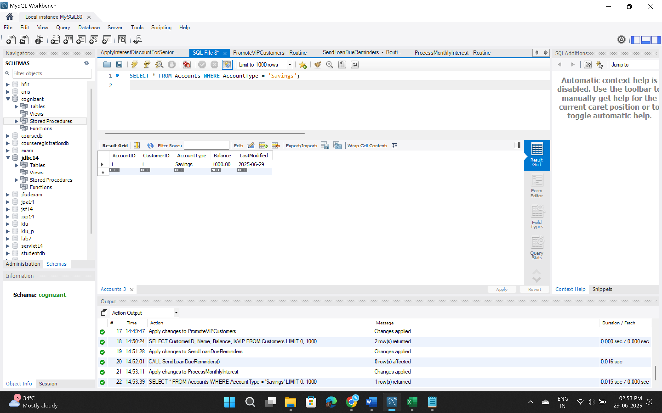

**Scenario 2:** The bank wants to implement a bonus scheme for employees based on their performance.

CREATE DEFINER=`root`@`localhost` PROCEDURE `UpdateEmployeeBonus`(

IN dept_name VARCHAR(50),

IN bonus_percent DECIMAL(5,2)

)

BEGIN

UPDATE Employees

SET Salary = Salary + (Salary * bonus_percent / 100)

WHERE Department = dept_name;

END

CALL UpdateEmployeeBonus('IT', 10);

**Scenario 3:** Customers should be able to transfer funds between their accounts

CREATE DEFINER=`root`@`localhost` PROCEDURE `TransferFunds`(

IN source_account_id INT,

IN target_account_id INT,

IN transfer_amount DECIMAL(10,2)

)

BEGIN

DECLARE source_balance DECIMAL(10,2);

-- Get current balance of source account

SELECT Balance INTO source_balance

FROM Accounts

WHERE AccountID = source_account_id;

-- Check if sufficient balance

IF source_balance >= transfer_amount THEN

-- Deduct from source

UPDATE Accounts

SET Balance = Balance - transfer_amount

WHERE AccountID = source_account_id;

-- Add to target

UPDATE Accounts

SET Balance = Balance + transfer_amount

WHERE AccountID = target_account_id;

ELSE

SIGNAL SQLSTATE '45000'

SET MESSAGE_TEXT = 'Insufficient funds in source account';

END IF;

END

CALL TransferFunds(1, 2, 300.00);



